Alex Powers, Rachel Brinkley, and Hannah Huntoon

**Topic:** Missing Persons in the U.S.

**Rationale:** We chose this dataset because we are interested in determining what, if any, factors are common among missing persons in the U.S. We will focus on race, gender, age, and geographical location to uncover any similarities or common themes within the dataset. Our charts and maps will help us visualize potential differences/similarities within the dataset and help us to convey these insights in a clear, straightforward manner.

**Dataset:**<https://public.opendatasoft.com/explore/dataset/namus-missings/table/?disjunctive.raceethnicity&sort=modifieddatetime>

**Dataset:**

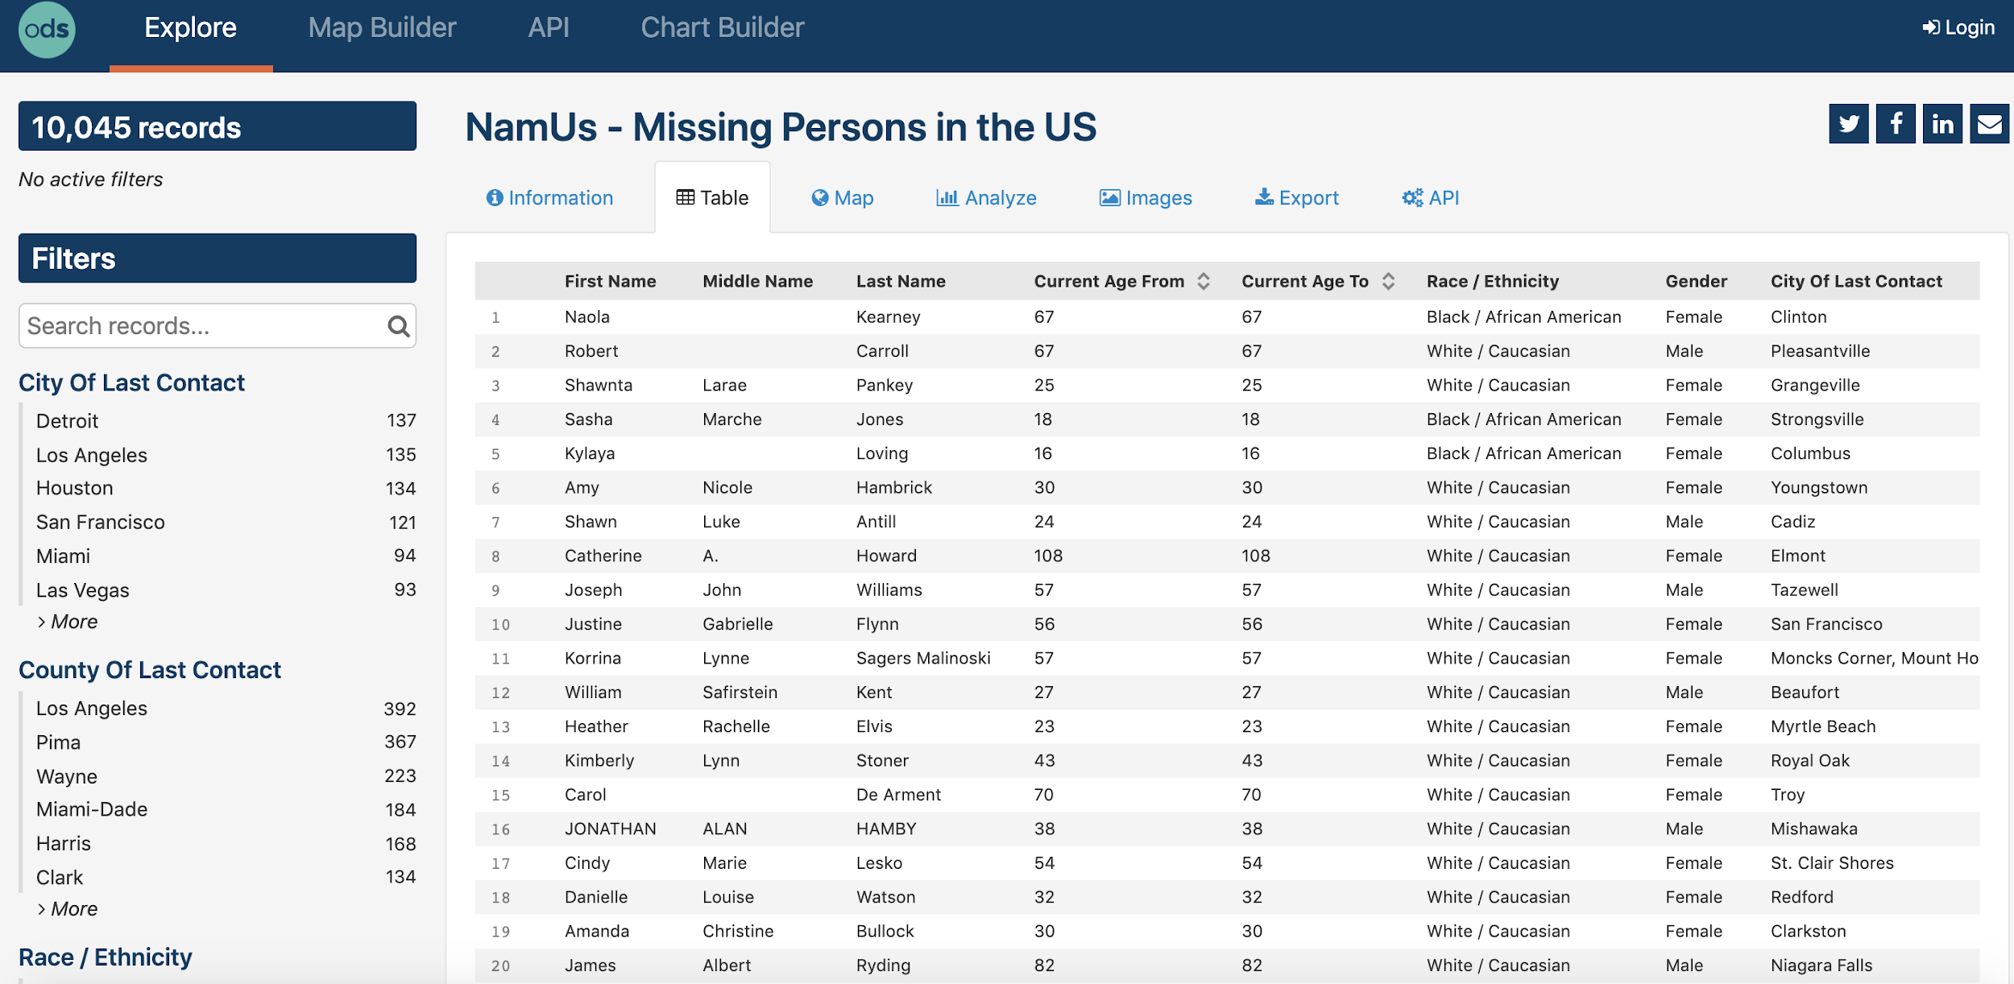

**Visualization Inspiration:**

* Leaflet Interactive Maps

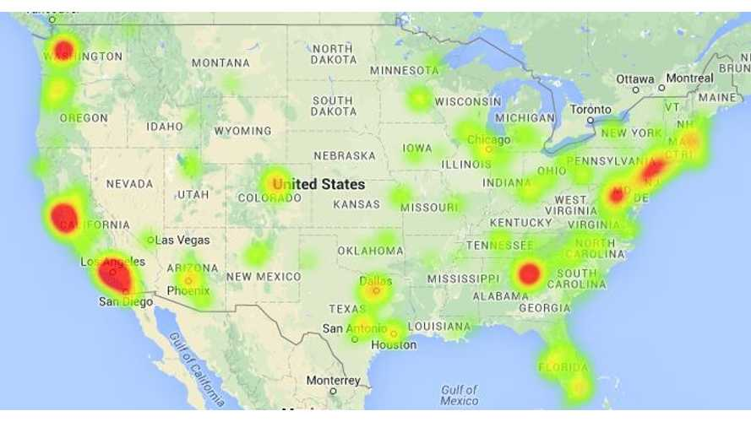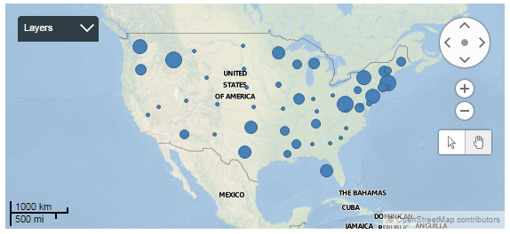

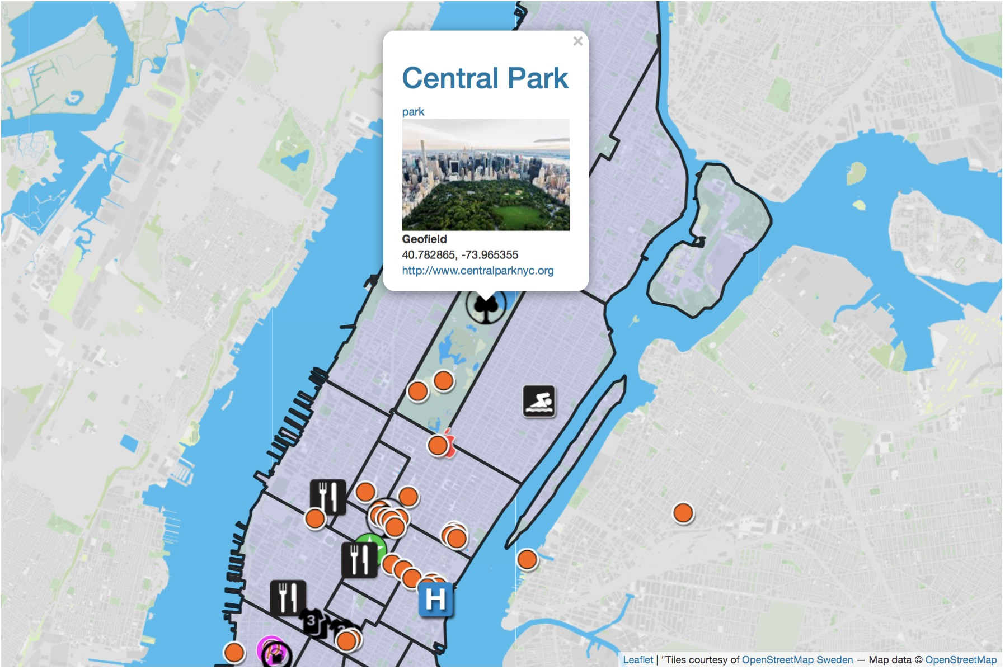

* Plotly Dashboard Example:

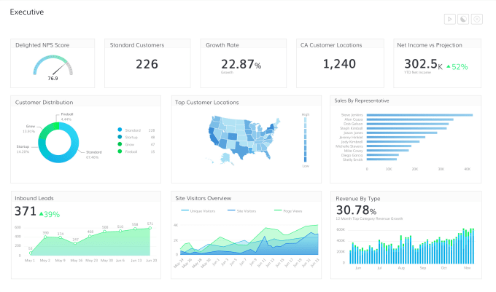

**Our Project Design:**

* Dashboard with multiple visualizations
* User is able to click into graphs/maps and interact with the data
* One map of the U.S with markers that are clickable. When clicked the markers will share more in-depth data

**Github Repository:**

[**https://github.com/alexrva/leaflet-project**](https://github.com/alexrva/leaflet-project)